**CREATING MICRO SERVICES FOR ACCOUNT AND LOAN**

**1. Account Microservice**

**Account.java (Model)**

package com.cognizant.account.model;

public class Account {

private String number;

private String type;

private double balance;

public Account(String number, String type, double balance) {

this.number = number;

this.type = type;

this.balance = balance;

}

public String getNumber() { return number; }

public String getType() { return type; }

public double getBalance() { return balance; }

}

**AccountController.java (Controller)**

package com.cognizant.account.controller;

import com.cognizant.account.model.Account;

import org.springframework.web.bind.annotation.*;

@RestController

@RequestMapping("/accounts")

public class AccountController {

@GetMapping("/{number}")

public Account getAccount(@PathVariable String number) {

return new Account(number, "savings", 234343);

}

}

**AccountApplication.java (Main Class)**

package com.cognizant.account;

import org.springframework.boot.SpringApplication;

import org.springframework.boot.autoconfigure.SpringBootApplication;

@SpringBootApplication

public class AccountApplication {

public static void main(String[] args) {

SpringApplication.run(AccountApplication.class, args);

}

}

**pom.xml (Dependencies)**

Make sure your generated project includes:

<dependencies>

<dependency>

<groupId>org.springframework.boot</groupId>

<artifactId>spring-boot-starter-web</artifactId>

</dependency>

</dependencies>

**Test in browser:**

http://localhost:8080/accounts/00987987973432

**Output:**

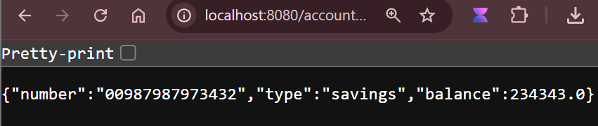

**2. Loan Microservice**

**Loan.java (Model)**

package com.cognizant.loan.model;

public class Loan {

private String number;

private String type;

private double loan;

private double emi;

private int tenure;

public Loan(String number, String type, double loan, double emi, int tenure) {

this.number = number;

this.type = type;

this.loan = loan;

this.emi = emi;

this.tenure = tenure;

}

public String getNumber() { return number; }

public String getType() { return type; }

public double getLoan() { return loan; }

public double getEmi() { return emi; }

public int getTenure() { return tenure; }

}

**LoanController.java (Controller)**

package com.cognizant.loan.controller;

import com.cognizant.loan.model.Loan;

import org.springframework.web.bind.annotation.*;

@RestController

@RequestMapping("/loans")

public class LoanController {

@GetMapping("/{number}")

public Loan getLoan(@PathVariable String number) {

return new Loan(number, "car", 400000, 3258, 18);

}

}

**LoanApplication.java (Main Class)**

package com.cognizant.loan;

import org.springframework.boot.SpringApplication;

import org.springframework.boot.autoconfigure.SpringBootApplication;

@SpringBootApplication

public class LoanApplication {

public static void main(String[] args) {

SpringApplication.run(LoanApplication.class, args);

}

}

**application.properties**

server.port=8081

**Test in browser:**

http://localhost:8081/loans/H00987987972342

**Output:**

